## TEST CASE REVIEW PROCESS

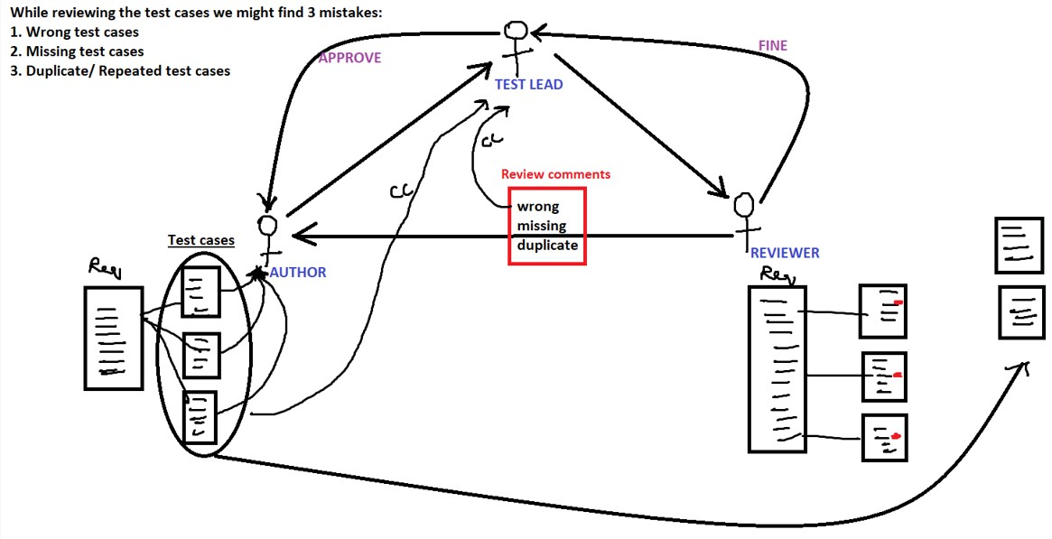

**On what basis you assign someone to review test case?**

They will assign to the person:

1. Who is working on a similar or related module in the project.
2. Who has worked on same module in the previous project.
3. Who has been working in the project since the beginning knows every corner of the product.
4. Who is responsible, and who will understand the requirement very fast and identify more mistakes.

**Review ethics:**

1. Always review the content, and not the author.
2. Reviewer should spend more time in finding the mistakes rather than giving the solution for it
3. Even after review if there are still any mistakes, both author and reviewer are responsible

**Why we review test case (OR) if I give you the test cases what is the approach to review the test cases (OR) what kind of mistakes will you find while reviewing the test case?**

1. I will look into the header of the test case and understand the req for which test case is written and then go to body of the test cases and try to find:
   1. Missing scenarios b. Wrong scenarios c. Repeated scenarios
2. I will check whether organized or not so that when executed it should take less time
3. I will check whether it is simple to understand so that the it is given to ne TE he should be able to execute without asking any questions
4. I will look into the header of the test case and try to find:
   1. All the attributes are covered or not
   2. Check whether content in all the attributes are cover or not
5. I will check whether test case format is according to standers defined in the project

**TEST CASE REVIEW DOCUMENT**

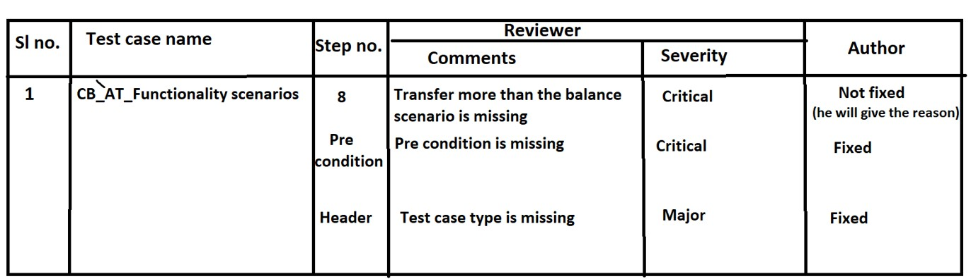

**Procedure to write the test case**

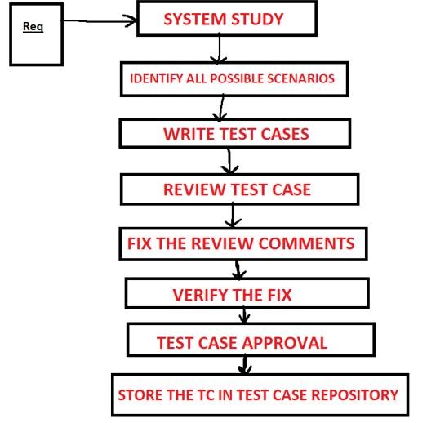

1. ***System study:***

Read the requirement, understand the requirement, and if you have any queries interact with the customer, B.A.

1. ***Identify all possible scenarios:***

i.Identify

ii.Brainstorming sessions

* + - * 1. Presentation of feature: Improved product knowledge
        2. Present scenarios: Missing, Wrong and Repeated scenarios

iii.Measure the efficiency of Brain storming session

1. ***Write the test cases:*** 
   * + - Document the identified scenarios Group all related scenarios.
       - Prioritize the scenarios within each group.
       - Apply test case design technique.
       - Use standard test case format

1. ***Store in test case repository:***

Test case repository: It is a centralized place where all the test cases are stored.

Test Suite: Collection/ group of related test cases

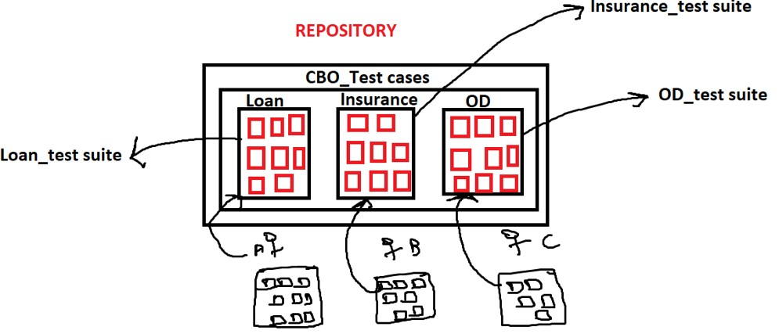

***Q.1 Where do you write the test case?***

* + 1. In Excel sheet
    2. In Word file
    3. In a test case management tool

Ex: Test link, ALM

***Q.2 Where do you store the test cases?***

* + 1. In a shared folder
    2. In a test management tool Ex: Test link, ALM
    3. In a version control tool Ex: CVS, Subversion

***Q.3 How do you ensure that your test coverage is good? Or How do you convince you customer / management/developer that you have tested everything?***

My test coverage is good because my test cases are good. My test cases are good because I have followed a strict procedure Strict procedure means:

* + 1. I did a thorough system study because of which I had a deeper knowledge of the product because of that I was able to find more numbers of scenarios
    2. I identified all possible scenarios then I did a brainstorming session because if which I was able to find more numbers of scenarios
    3. While writing test case I applied test case design technique because of that there was improvement in the coverage
    4. I got all my test cases reviewed and found missing scenarios because of this there was as improvement in the coverage
    5. While executing test cases, I identified few new scenarios, I added them back into the test cases because of this there was as improvement in the coverage
    6. Also, I performed Adhoc testing because of that there was an improvement in the coverage
    7. I wrote traceability matrix and ensured that every requirement has got at least one test case because of that there was an improvement in the coverage